Session – 1
Question 1. Install Python (latest version) and VS Code on your computer, then take a screenshot of both the Python installation confirmation and the VS Code welcome screen.
Answer –
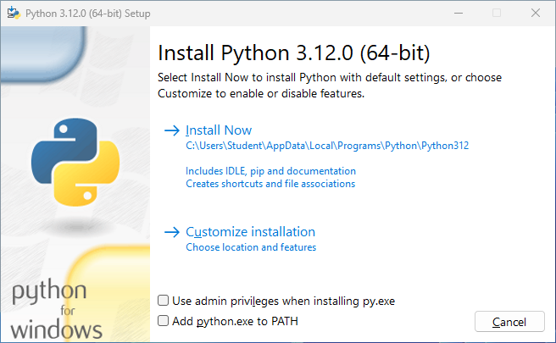

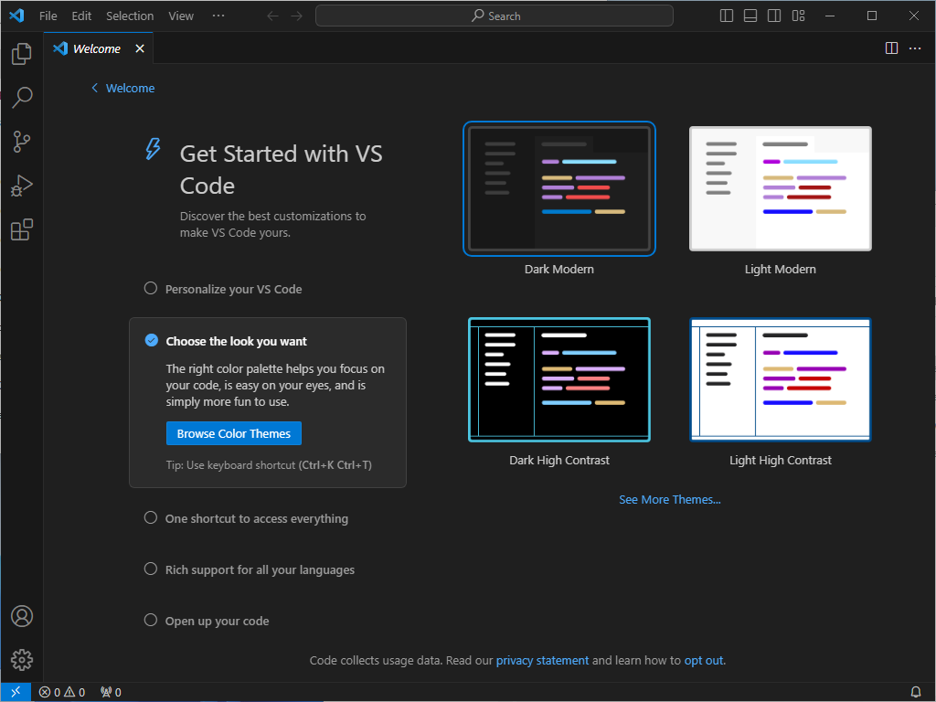

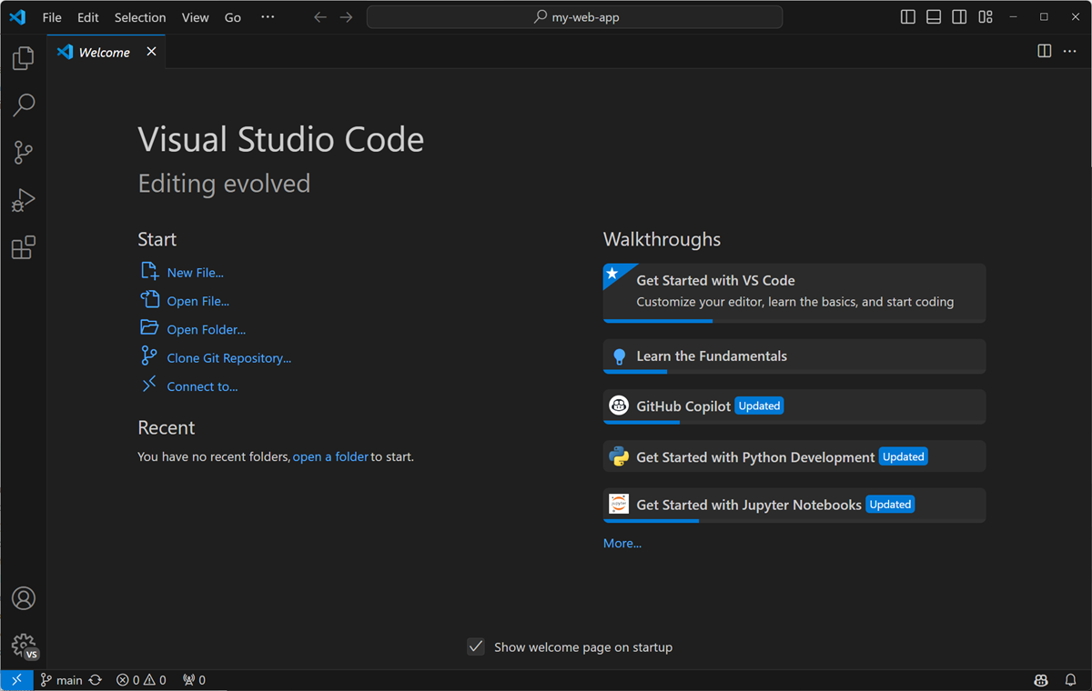

Question 5. Explain the difference between how Python executes code versus how C or Java executes code, using your own words and a simple example for each.
Answer –
Python:
Python code is generally executed by the Python interpreter. Python first compiles the source code into bytecode, and then the Python virtual machine executes that bytecode.
Ex.
print("Hello")
C:
C code is first compiled into machine code by a compiler such as GCC. Then the computer directly runs the compiled executable.
Ex.
#include <stdio.h>

int main() {
printf("Hello");
return 0;
}
Java:
Java code is compiled into bytecode (.class files). The Java Virtual Machine (JVM) then runs that bytecode, using interpretation and/or JIT compilation.
Ex.
class Hello {
public static void main(String[] args) {
System.out.println("Hello");
}

